Devin Hardy

00076619

[Dhardy2@my.athens.edu](mailto:Dhardy2@my.athens.edu)

Ex 1:

Added columns to split the table of contents for the menu.

Placed a jumbotron on the home page for the welcome.

Added a carousel for some of the images of the menu.

Added a badge to mark what drinks have alcohol

Added a border around the different menus

Rounded the corners of an image in the home page

Created a dropdown button that directs to a specific part of the menu

Ex 2:

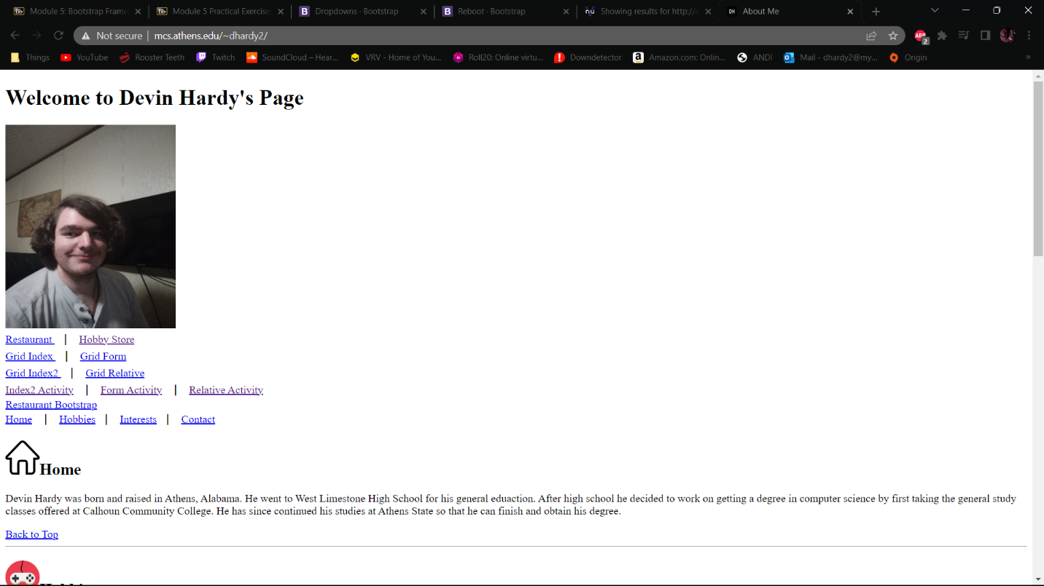

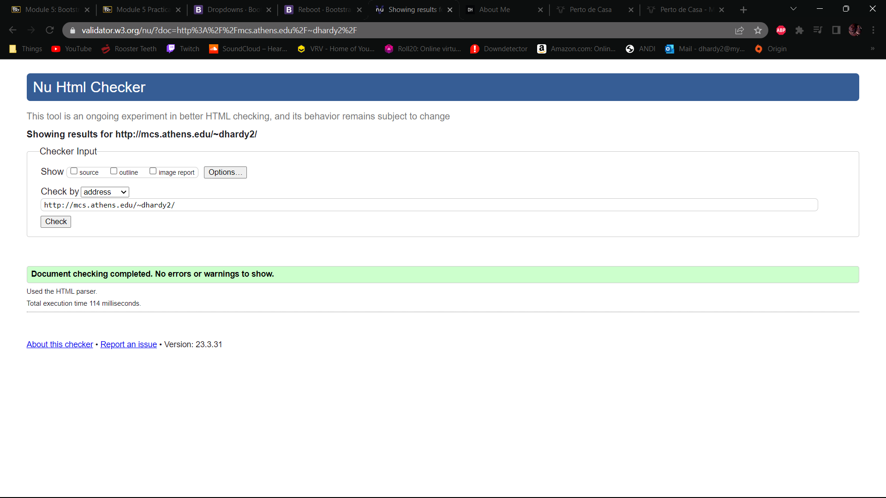

Ex 3:

HardyBrasilHomeBtsp

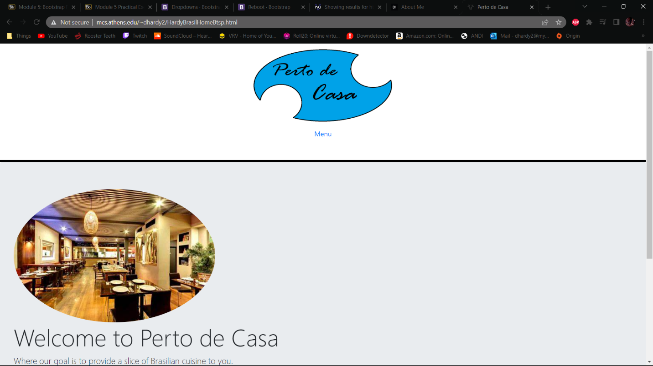

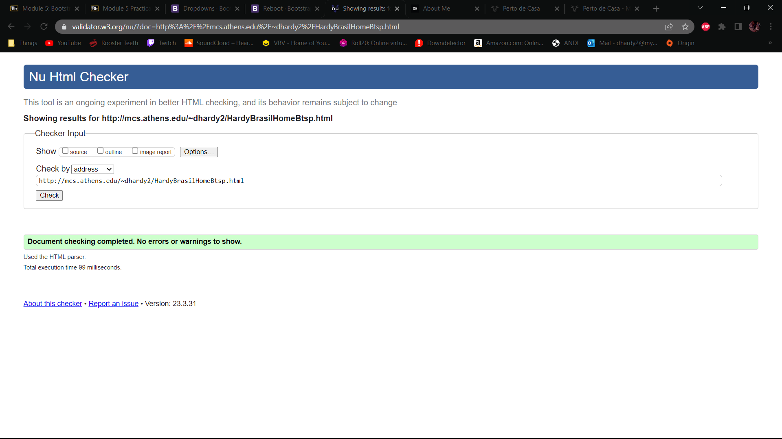

HardyBrasil2

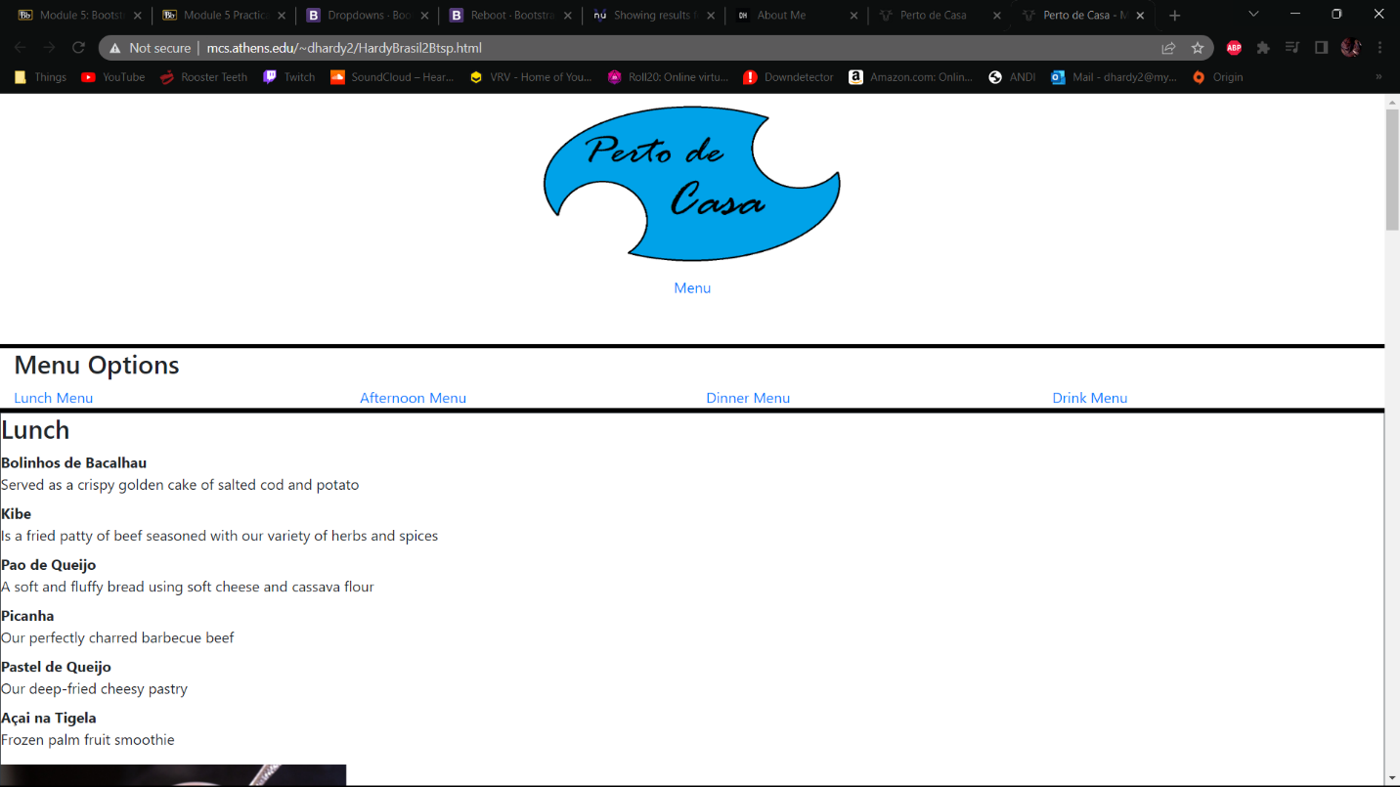

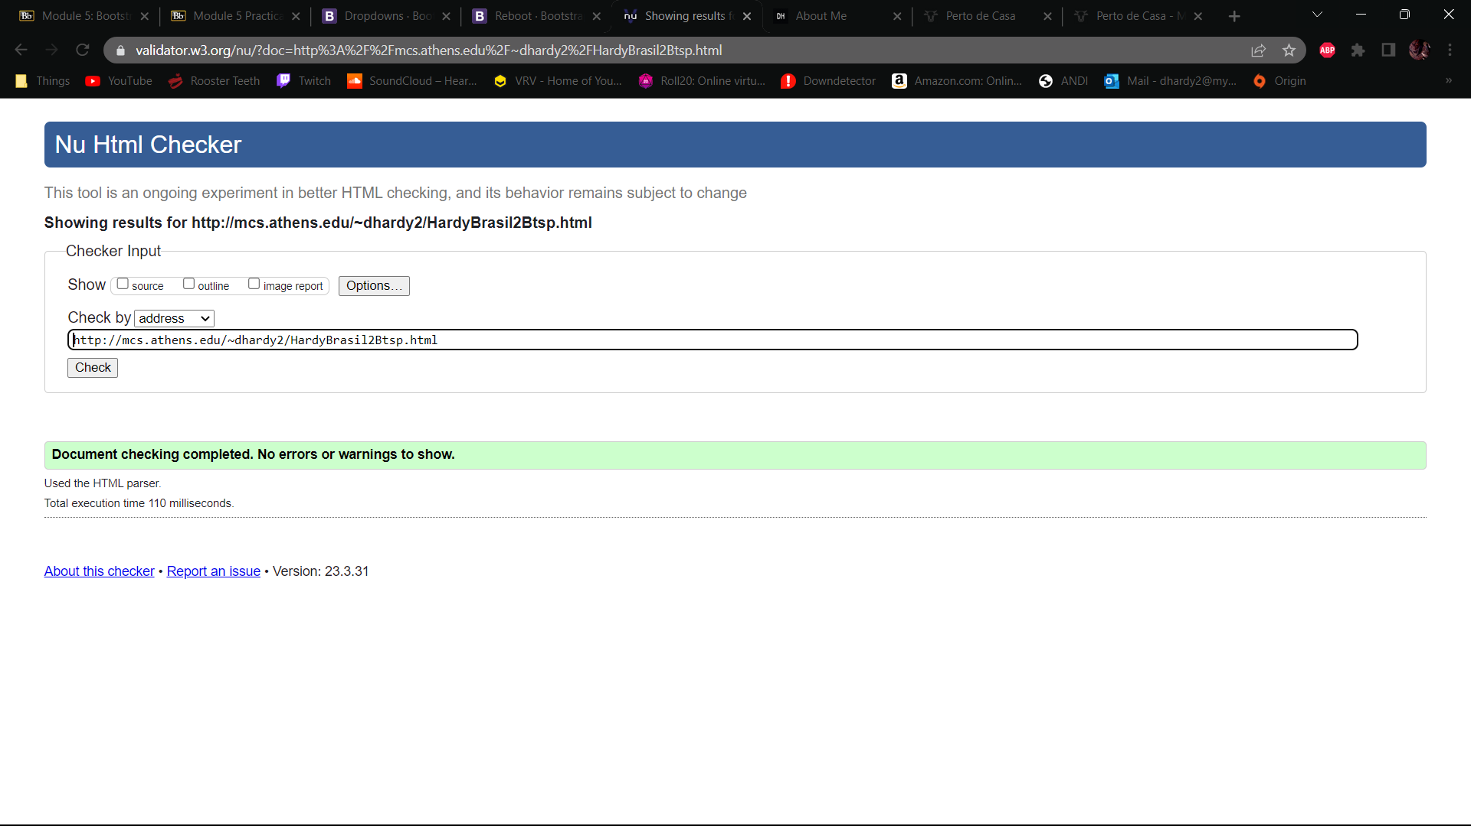

CSS Validator

